42U ENCLOSURE 19" CABINET 600X800 FLOOR STANDING DATA RACK - VALUCAB
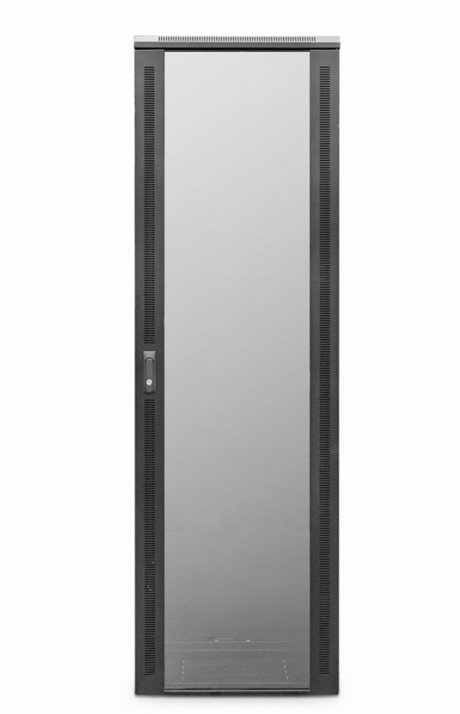

DESCRIPTION
The LMS Data EcoNetCab is the defacto standard in offering great choice and quality enclosure solutions, be it structured cabling for your copper or fibre networking, LAN or WAN networking deployment or broadcast A/V for companies of all sizes. Designed for the installer and IT manager, all enclosure come with useful features to make your installation that much easier, together with bundled free accessories you need to get your new installation up and running.

TECHNICAL SPECIFICATIONS
42U high 600W 800D
• 19" standard
• Colour: Black (Powder-coated RAL 9005)
• Dimensions: 600 (width) x600(depth) x2050mm (height - inc. castors)
• Front tempered glass door (lockable)
• Left/right hinged front/rear doors
• Removable side panels for easy access
• U-numbered uprights for rack-mount product alignment
• Multiple cable entry glands for exact power and cabling entry

PRODUCT INFO
SKU/MNP: CAB-FE-42U-68NA
EAN: 8400800032454
Dimensions: 600 (width) x800(depth) x2050mm (height - inc. castors)

SUPPLIED WITH
Standard/Shipping Castors (Fitted): Set of 4 adjustable Jacking Feet (Supplied): Standard M6 Cage Nuts and Bolts (Supplied): Hex Adjusting Key (Supplied)

FILES
﻿Specification Sheet (PDF)

